Requirements specification document

Recipe Manager - AnnaAndSteffi Development

Coded by Anna Youngberg (user interface genius) and Stephanie Wilson (database wizard) in the spring semester of 2014 for CS302

# Introduction

The Recipe Manager is a light, easy-to-use, client-based software that can be used as a digital cookbook. With the Recipe Manager, you will never forget your favorite recipes again! You can easily add as many recipes to the Recipe Manager as you want, and the Recipe Manager will store them for as long as you want. Because the recipes are stored on your computer, all of your most secret recipes are safe from hackers that might steal them if you stored them on the internet. The Recipe Manager allows you to categorize your recipes according to criteria such as "Dinner," "Appetizer," "Snack," "Breakfast," and more. You can keep track of which recipes use a particular main ingredient using subcategories such as "Bread," "Poultry," and "Beef," and the Recipe Manager's helpful search feature allows you to easily find every recipe you have submitted that contains any ingredient you want to search for. You can also track which recipes are your favorites using the Recipe Manager's easy rating system. Do you have a limited amount of time to make dinner? Use the Recipe Manager's Search to find just the recipes that you have time to make. You can modify a recipe's information and instructions at any time, and the Recipe Manager's comment system allows you to make any notes you want on a recipe. Sharing your recipes is easy, too, because the Recipe Manager has a feature that allows you to email your recipe to anyone you want at the touch of a button. If you decide you no longer want to keep a recipe in your Recipe Manager, you can selectively delete recipes too.

# Glossary

We here at *AnnaAndSteffi Development* believe that documentation should be user-friendly. We try not to use hard or confusing terms here; but here are a few definitions to make sure we're clear:

**Recipe Manager** - The software, which displays itself to the user in the form of a GUI.

The **database** - A SQL EXPRESS 2012 SP1 instance that is used to store all the recipe data

**GUI** - A Graphical User Interface, which is a window on the user's computer that displays information and allows the user to input information, via form fields and buttons.

**URI** - A Uniform Resource Identifier, which is a string of characters used to identify a web resource. The Recipe Manager uses this as part of emailing recipes.

# User Requirements Definition

* The Recipe Manager must allow users to create, edit, and delete recipes
* The Recipe Manager must allow users to store at least 100 recipes
* The Recipe Manager must allow users to give their recipes categories and subcategories, and search for recipes based on these and other criteria
* The Recipe Manager must have a GUI that allows users to view single recipes and allow users to view a list of all recipes that have been entered into itself
* The Recipe Manager must have the ability to email recipes to user-inputted email addresses

# **Diagrams**

# Use case: Recipe Manager software

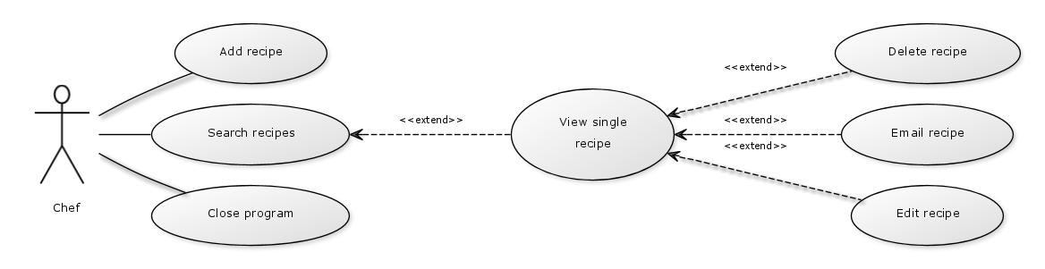

Recipe Manager tabular description

|  |  |
| --- | --- |
| Actors | The actor is a chef who is accessing the Recipe Manager. Anyone may be a chef. |
| Description | The chef can choose to add a recipe to the Recipe Manager, search through the recipes already in the Recipe Manager, or exit the Recipe Manager. After searching the existing recipes, the chef can choose to view detailed information on a single recipe. After choosing to view a single recipe, the chef can choose to edit the recipe, delete the recipe, or email the recipe. |
| Data | The data for recipes includes the recipe's name, the recipe's category and subcategory, the prep time for the recipe, the recipe's rating, a list of ingredients, and a list of instruction steps. |
| Stimulus | The chef runs the Recipe Manager program |

(continued on next page)

# Use case: Add recipe

|  |  |
| --- | --- |
| Actors | Chef |
| Description | The chef can add recipes to the database. The chef is required to submit a name, at least one ingredient, and at least one instruction step; and the chef may also give a rating, category, subcategory, preptime, and image. |
| Data | Recipe information |
| Stimulus | The chef presses the "Add recipe" button |
| Response | The user is returned to the menu after the recipe is submitted successfully. |
| Comments | The data is automatically stored in the database when the user presses the "Submit recipe" button. |

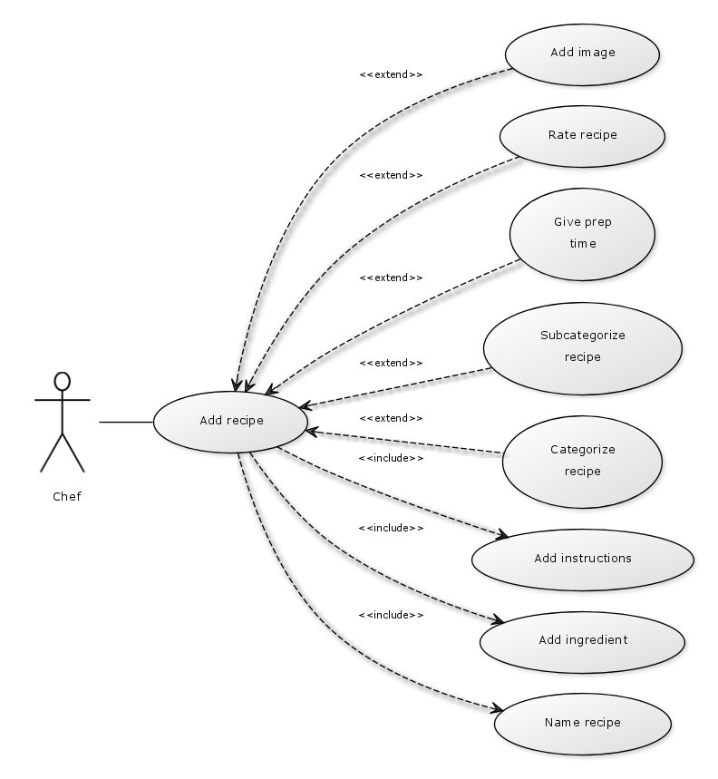

# Use case: Search for recipes

|  |  |
| --- | --- |
| Actor | Chef |
| Description | The chef can choose to search for recipes. When searching for recipes, the chef may view all recipes by pressing search without specifying any filters, or the chef may filter the results to recipes that match his submitted name, rating, ingredient, category, subcategory, instruction step, or preptime. |
| Data | Recipe information, user-submitted search filters |
| Stimulus | The chef presses the "Search recipes" button on the main menu |
| Response | When the chef presses "Search," a list of all recipes that meet the criteria given are displayed in the Recipe Manager client window. If no criteria is given, all recipes in the database are displayed. When the chef clicks on a recipe and presses the "Select" button, the system displays the "View recipe" screen with that recipe's detailed information. |
| Comments | None |

# Sequence diagram: Email recipe

The "Email Recipe" feature is carried out by building a mailto URI string, and using that with the Java Desktop access to open the user's default email client and create an email with the body populated with the selected recipe's data. Within the email client, the user will provide the email address to which the recipe should be sent. The user can optionally give their own subject line and make their own comments in the body of the email as well, before instructing the email client to send the email.

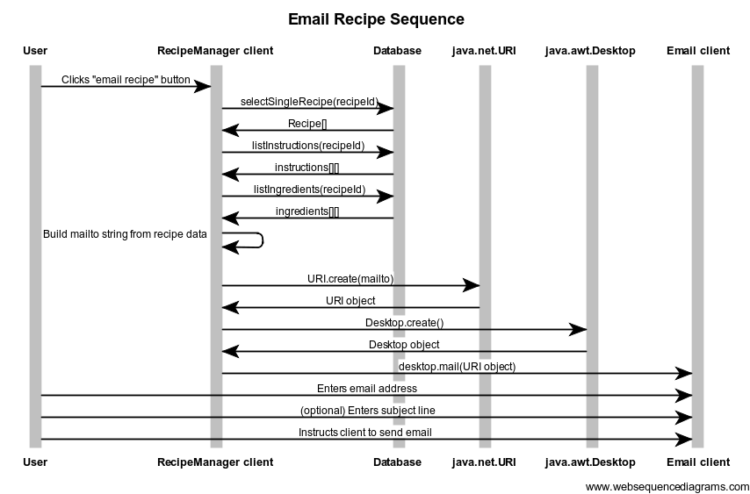

(continued on next page)

# Recipe Manager Activity Diagram

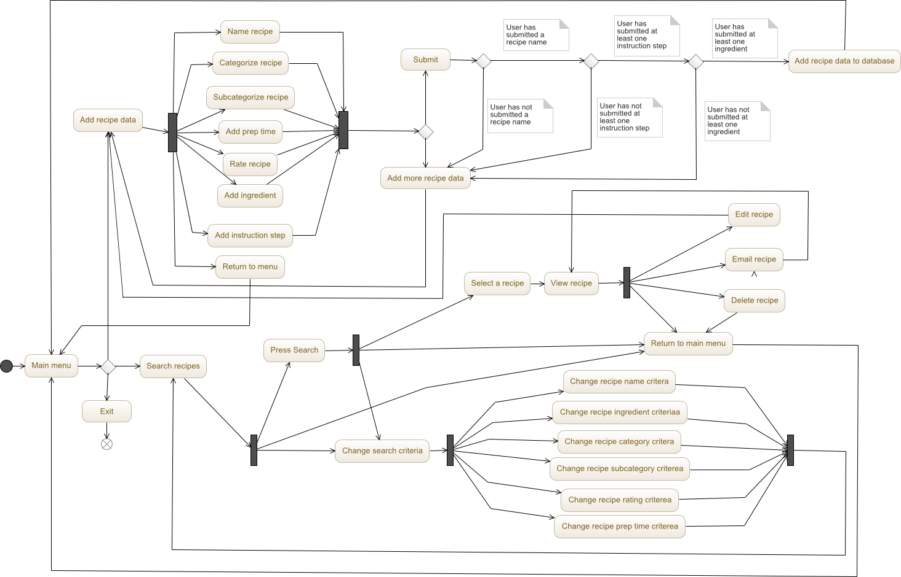

# Class Diagrams

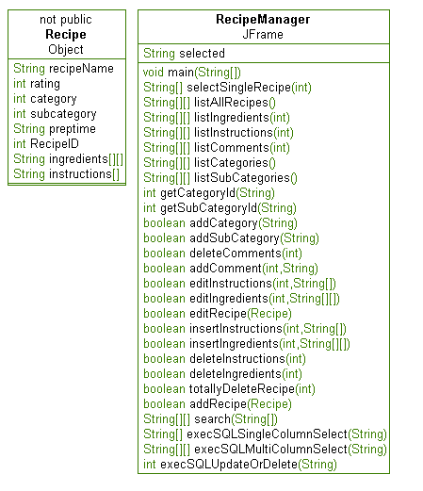

(continued on next page)

# Database diagram

